A Project Report on
Serverless – Cloud Video Editor For Social Media
submitted in partial fulfillment of the requirements for the award of the degree of
BACHELOR OF ENGINEERING
By
Raj Patil: 22106135
Harsh Kalsekar: 23106042
Krinjal Kocharmutha: 23106030
Prathamesh More: 23106001
Under the Guidance of
Prof. Vijaya Bharathi Jagan

Department of Computer Science & Engineering
(Artificial Intelligence & Machine Learning)
A. P. SHAH INSTITUTE OF TECHNOLOGY, THANE
(2025-2026)
CERTIFICATE
This is to certify that the project entitled “Serverless – Cloud Video Editor For Social Media” is a bonafide work of Raj Patil (22106135), Harsh Kalsekar (23106042), Krinjal Kocharmutha (23106030), Prathamesh More (23106001) submitted to the University of Mumbai in partial fulfilment of the requirement for the award of the degree of Bachelor of Engineering in Computer Science & Engineering (Artificial Intelligence & Machine Learning)
________________ |  | _______________
Prof. Vijaya Bharathi Jagan |  | Prof. Yogeshwari Hardas
Project Guide |  | Project Co-Ordinator
________________ |  | ________________
Dr. Jaya Gupta |  | Dr. Uttam D Kolekar
Head of Department |  | Principal

Project Report Approval for T. E.
This project report entitled Severless – Cloud Video Editor for Social Media by Raj Patil, Harsh Kalsekar, Krinjal Kocharmutha, Prathamesh More is approved for the degree of Bachelor of Engineering in Computer Science & Engineering (Artificial Intelligence & Machine Learning), 2025-26.
Examiner Name |  | Signature
1. _________________________ |  | __________________
2. _________________________ |  | __________________
Date:
Place:

Declaration
We declare that this written submission represents my ideas in my own words and where others' ideas or words have been included, I have adequately cited and referenced the original sources. I also declare that I have adhered to all principles of academic honesty and integrity and have not misrepresented or fabricated or falsified any idea/data/fact/source in my submission. I understand that any violation of the above will be cause for disciplinary action by the Institute and can also evoke penal action from the sources which have thus not been properly cited or from whom proper permission has not been taken when needed.
__________________
Raj Patil
22106135
__________________
Harsh Kalsekar
23106042
__________________
Krinjal Kocharmutha
23106030
__________________
Prathamesh More
23106001
Date:

Abstract
Serverless Video Editing Software is a cloud-based automated video processing system developed to simplify and accelerate the generation of short video clips from long video content. The project focuses on reducing manual editing effort by using serverless cloud services to perform video analysis, speech extraction, timestamp identification, and clip generation in an efficient manner. In the current digital environment, short-form video content is widely used across social media and online communication platforms. However, manually identifying important segments from long videos requires time and technical expertise. This project addresses that problem by creating an automated workflow where users upload a video through a web interface and the system processes it through cloud-based services without requiring dedicated servers. The uploaded video is stored in Amazon S3, where serverless functions are triggered to extract audio from the video using FFmpeg. The extracted audio is then converted into text using the Vosk speech recognition model. Based on transcript analysis, relevant timestamps are identified and passed to the video clipping module. Short clips are then generated automatically and stored securely for download. The system uses AWS Lambda, API Gateway, and Step Functions to manage different processing stages in an event-driven architecture. The proposed system supports sustainable technological development by utilizing serverless architecture to optimize computing resource usage and reduce operational overhead. It aligns with SDG 9: Industry, Innovation and Infrastructure by promoting scalable and efficient cloud-based media processing solutions. Additionally, it contributes to SDG 12: Responsible Consumption and Production by minimizing unnecessary resource consumption and improving energy efficiency. The proposed software provides an effective solution for content creators, educational users, and digital media platforms that require fast generation of short clips from large video files while minimizing human intervention.

Keywords: Serverless Computing, Video Editing, AWS Lambda, Speech-to-Text, Amazon S3, Step Functions, Cloud Processing, Short Video Generation

CONTENTS
- Introduction 1
1.1 Background 1
1.2 Motivation 2
1.3 Aim & Scope of the Project 3
1.4 Relevance to Sustainable Development Goals 3
- Literature Survey 4
2.1 Traditional Video Summarization Techniques 5
2.2 Deep Learning Based Video Summarization 5
2.3 Generative and Attention-Based Summarization Models 5
2.4 Survey of Modern Video Summarization Approaches 6
2.5 Speech-Based Semantic Highlight Detection 6
2.6 Serverless Processing for Video Automation 6
- Limitations in Existing Systems 8
- Problem Statement & Objectives 10
4.1 Problem Statement 10
4.2 Objectives 11
- Proposed System & Methodology 12
5.1 System Overview 12
5.2 System Architecture 13
5.3 System Methodology 14
- Experimental Setup 18
6.1 Frontend Setup 18
6.2 Backend Setup 19
6.3 Development Environment 20
- Results & Discussion 22
7.1 Frontend Processing Result 23
7.2 Serverless Workflow Execution Result 24
7.3 Output Generation and Final Result 25
- Conclusion & Future Scope 26
8.1 Conclusion 26
8.2 Future Scope 27
- References 28

LIST OF FIGURES
Figure 1 : Taxonomy of Video Summarization Techniques 7
Figure 2 : Proposed System Architecture 14
Figure 3 : Workflow Orchestration Using AWS Step Functions 17
Figure 4 : Frontend Processing Interface 23
Figure 5 : Workflow Execution in AWS Step Functions 24
Figure 6 : Generated Short Video Output 25

LIST OF TABLES
Table 3.1: Summary of limitations of existing systems 9

ABBREVIATIONS
API Application Programming Interface
AWS Amazon Web Services
CSS Cascading Style Sheets
FFmpeg.............. Fast Forward Moving Picture Experts Group
HTML HyperText Markup Language
HTTP Hypertext Transfer Protocol
JSON JavaScript Object Notation
ML Machine Learning
REST Representational State Transfer
S3 Simple Storage Service
SDG Sustainable Development Goal
STT Speech-to-Text
UI User Interface
URL Uniform Resource Locator
Vosk Offline Speech Recognition Toolkit

Chapter 1

Introduction

1.1 Background
The rapid growth of digital communication platforms has significantly increased the use of video content across various domains such as education, entertainment, marketing, online communication, and social media. Video has become one of the most effective forms of information sharing because it combines visual and audio elements to deliver content in an engaging manner. However, long-form video content often contains only selected segments that are useful for short-form viewing or targeted content delivery.
With the popularity of short video platforms and social media applications, there is increasing demand for extracting important moments from longer videos and presenting them in shorter, easily consumable formats. Traditionally, this process requires manual editing, where users review long videos, identify relevant timestamps, trim clips, and export them using editing software. This manual workflow requires considerable time, technical knowledge, and access to dedicated video editing tools.
Conventional video editing systems also depend on local hardware resources, which can become inefficient when processing large files or handling multiple editing tasks simultaneously. Such systems require software installation, storage capacity, and continuous maintenance, making them less suitable for scalable or cloud-based environments.
Recent advancements in cloud computing have introduced serverless architectures that enable event-driven execution of tasks without managing permanent server infrastructure. Serverless systems allow resources to be allocated only when needed, reducing infrastructure cost and improving scalability. This approach is highly suitable for video processing tasks where computational demand varies depending on file size and user activity.
The proposed Serverless Video Editing Software applies serverless cloud technologies to automate the video editing process. It enables users to upload videos through a web interface, after which the system automatically extracts audio, converts speech into text, analyzes transcripts, and identifies timestamps for short clip generation. By integrating AWS cloud services, the system performs these operations efficiently while minimizing manual intervention and infrastructure complexity.

1.2 Motivation
The primary motivation behind this project is the increasing requirement for quick generation of short video content from long recordings. Content creators, educators, and digital media users frequently need short clips from lectures, interviews, presentations, or recorded discussions for sharing on social platforms or for targeted communication. Manually identifying important segments from long videos is repetitive, time-consuming, and often inefficient.
Many available video editing tools are designed for manual editing and require technical expertise. Users must review the complete video, locate useful sections, and manually perform trimming and exporting operations. This process becomes challenging when multiple videos need to be processed regularly.
Another important motivation is the need for scalable video processing solutions that do not depend on expensive computing infrastructure. Traditional server-based systems require continuous resource allocation even when processing demand is low. In contrast, serverless cloud architecture allows processing tasks to execute only when triggered, making it more cost-effective and scalable.
The project is also motivated by the practical application of speech recognition and transcript analysis in media processing. By converting spoken content into text, meaningful timestamps can be identified automatically, which reduces human effort in locating useful video segments.
Furthermore, the project provides an opportunity to explore how cloud-based automation can improve media workflows by combining storage services, serverless functions, workflow orchestration, and speech processing into a single integrated system.

1.3 Aim & Scope of the Project
The aim of this project is to develop an automated serverless video editing system capable of generating short video clips from long videos through cloud-based processing.
The system allows users to upload video files through a web interface, after which the video is processed automatically. Audio is extracted and converted into text using speech recognition. Transcript analysis helps determine useful timestamps, and short clips are generated accordingly.
The scope of the project includes video upload, cloud storage, audio extraction, speech-to-text conversion, transcript-based timestamp generation, automated video clipping, and secure output delivery. The system mainly focuses on reducing editing effort while improving scalability and cost efficiency through serverless architecture.

1.4 Relevance to Sustainable Development Goals
The proposed Serverless Video Editing Software contributes to the advancement of digital innovation and cloud-based media processing, aligning with several United Nations Sustainable Development Goals (SDGs). In particular, the project supports SDG 9: Industry, Innovation and Infrastructure by promoting the development of modern serverless computing solutions that improve the efficiency, scalability, and accessibility of multimedia processing systems.
Additionally, the system contributes to SDG 12: Responsible Consumption and Production by optimizing computing resource utilization through serverless architecture. Unlike traditional server-based systems that continuously consume computing power, the proposed system executes processing tasks only when required, thereby reducing unnecessary resource consumption and improving energy efficiency.
By minimizing infrastructure dependency, reducing operational overhead, and encouraging efficient use of cloud resources, the proposed system supports sustainable technological development and promotes responsible digital processing practices in modern media environments.

Chapter 2

Literature Survey
The increasing popularity of short-form digital content has created a strong demand for systems that can automatically extract important segments from long-form videos. Video summarization has therefore emerged as an important research area in multimedia processing, where the main objective is to reduce video length while preserving essential information. Over the years, researchers have proposed multiple techniques ranging from simple visual frame selection to advanced deep learning and semantic analysis models. These methods differ in terms of computational complexity, accuracy, and practical deployment feasibility.
Early research in video summarization mainly focused on visual characteristics such as scene changes, frame differences, and motion detection. With the advancement of machine learning, more intelligent models were developed that could learn temporal patterns and identify highlight-worthy segments automatically. Recent studies have further expanded into semantic and speech-based analysis, where spoken content is used to detect important information, especially in lecture videos, podcasts, and interviews.
In addition to summarization algorithms, cloud computing has also influenced modern video processing systems. Serverless architectures now allow large media workflows to execute without continuously running infrastructure, reducing cost and improving scalability.
The literature relevant to the proposed project can therefore be organized into different technical categories such as traditional summarization methods, deep learning-based systems, semantic speech analysis, and serverless media processing. These categories help establish the academic foundation for the proposed Serverless AI-Based Automated Video Highlight Extraction System.

2.1 Traditional Video Summarization Techniques
Traditional video summarization techniques focused mainly on visual analysis of video frames. These systems selected representative frames by comparing color differences, scene transitions, and motion intensity. The main objective was to remove redundant frames while preserving the overall visual content of the video.
Although these methods were computationally simple, they often failed to identify semantically important segments because selection was based only on visual changes. In speech-heavy videos such as educational lectures or interviews, visually static frames may still contain highly important content. This limitation reduced the effectiveness of traditional summarization methods for modern digital content applications.

2.2 Deep Learning Based Video Summarization
Deep learning introduced significant improvements in video summarization by enabling systems to learn temporal relationships between frames. Zhou et al. proposed reinforcement learning-based video summarization where an intelligent agent learns to select important segments while preserving diversity and representativeness [1].
Further studies extended reinforcement learning methods to classification-based summarization, improving highlight detection quality [2]. Mahasseni et al. proposed adversarial LSTM-based summarization, where important frames were selected through unsupervised sequence learning [3]. These methods improved summary quality but required high computational resources and GPU-based execution.

2.3 Generative and Attention-Based Summarization Models
Generative models further improved summarization by preserving semantic diversity. Panda et al. proposed SUM-GAN, where generative adversarial learning was used to produce compact summaries while maintaining meaningful content [5].
Attention-based methods later improved temporal selection further. Fajtl et al. introduced attention mechanisms that allowed systems to focus on highly informative segments of the video [6]. Although these methods achieved strong performance, they remained expensive for lightweight cloud deployment.

2.4 Survey of Modern Video Summarization Approaches
A comprehensive survey by Zhang et al. categorized modern video summarization methods into supervised, unsupervised, and reinforcement learning-based approaches [7]. The survey highlighted that deep learning methods improved summarization quality but increased computational complexity.
Earlier work by Money and Agius also emphasized that summarization systems should preserve semantic meaning rather than simply reducing visual redundancy [8]. This concept is important for practical short-form content generation where contextual relevance matters more than frame diversity.

2.5 Speech-Based Semantic Highlight Detection
Speech-based summarization has become important for videos where spoken content carries most of the information. In such systems, speech recognition converts audio into transcript form, after which semantic scoring identifies important speech segments.
This approach is highly effective for lectures, interviews, and podcasts because semantic meaning is directly extracted from spoken content. It also reduces dependence on heavy visual models.

2.6 Serverless Processing for Video Automation
Recent developments in cloud computing have introduced serverless execution for multimedia workflows. In traditional systems, servers remain active continuously even when no processing tasks are running, which increases infrastructure cost. Serverless computing solves this problem by activating resources only when specific events occur, such as video uploads or API requests.
For video processing applications, serverless architecture is highly effective because media tasks require computing resources only during execution. Functions such as audio extraction, speech transcription, semantic analysis, and video clipping can be executed independently through event-driven cloud services.
The proposed project adopts serverless processing to automate video highlight generation. This approach improves scalability, reduces idle resource cost, and makes the system suitable for student-level and research-oriented media processing applications.
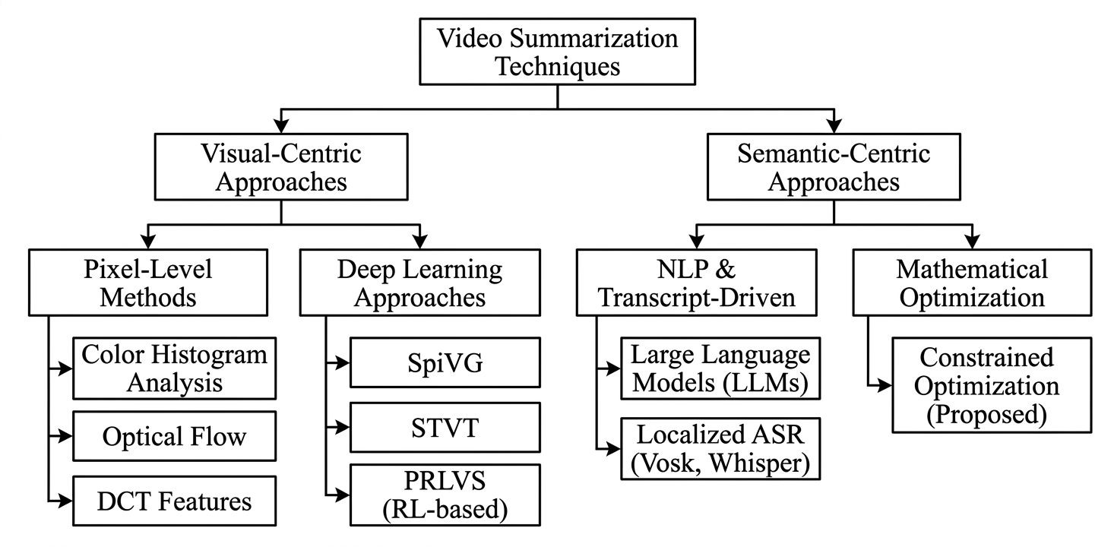
Figure 1 : Taxonomy of Video Summarization Techniques
The taxonomy of video summarization techniques is illustrated in Figure 1. As shown, the methods are broadly categorized into traditional visual-based approaches and modern semantic and learning-based techniques. Traditional methods rely on frame-level visual analysis, while semantic approaches focus on understanding contextual and speech-based information. The proposed system follows a semantic summarization approach, where transcript-based analysis is used to identify highlight-worthy segments.

Chapter 3

Limitations in Existing Systems
The field of video summarization and automated highlight extraction has witnessed rapid advancements due to the exponential growth of multimedia content across digital platforms. Researchers have explored a wide range of techniques including traditional visual feature-based methods, deep learning approaches, reinforcement learning-based models, and multimodal systems that combine audio, video, and textual information. These approaches aim to reduce manual effort and improve the efficiency of extracting meaningful segments from long-duration videos.
To understand the current research landscape and identify existing gaps, a detailed survey of relevant literature has been conducted. The selected research works have been analysed based on their methodologies, techniques, and performance characteristics. The review focuses on key areas such as visual-based summarization, deep learning techniques, reinforcement learning approaches, speech-to-text-based semantic analysis, and multimodal video understanding.
The following table presents a structured summary of the reviewed literature, highlighting the title of each work, publication details, key contributions, and identified limitations. This analysis provides a clear comparison of existing systems and helps in identifying the need for a more efficient, scalable, and cost-effective solution.

Table 3.1: Summary of limitations of existing systems
Title | Conference / Journal and Information Details | Key Points | Improvements Proposed | Citation
Video Summarization Using Deep Reinforcement Learning | AAAI Conference, 2018 | Uses reinforcement learning for key segment selection | High training complexity; GPU required | [1]
Video Summarisation by Classification with Deep Reinforcement Learning | BMVC, 2018 | Combines classification and reinforcement learning | Computationally expensive; requires labeled data and training time | [2]
Unsupervised Video Summarization with Adversarial LSTM Networks | IEEE CVPR, 2017 | Uses GANs and LSTM for unsupervised video summarization | Complex architecture; unstable training; high computational cost | [3]
Deep Summarization Network | IEEE CVPR, 2016 | Uses deep neural networks to generate summaries without labeled data | Requires large datasets; limited interpretability | [4]
SUM-GAN: Summarization of Videos Using Generative Adversarial Networks | IEEE AAAI, 2018 | GAN-based framework for generating diverse video summaries | High computational overhead; difficult training process | [5]
Spatiotemporal Attention-Based Video Summarization | IEEE CVPR, 2019 | Uses attention mechanisms to capture temporal dependencies in videos | Requires high-end hardware; expensive for deployment | [6]
A Comprehensive Survey on Video Summarization Techniques | ACM Computing Surveys, 2021 | Reviews traditional and deep learning-based summarization approaches | Highlights semantic gap and lack of unified solutions | [7]
Speech-Based Video Summarization Using Automatic Speech Recognition | IEEE / ACM Studies | Uses speech-to-text conversion to extract semantic information from videos | API cost, latency issues, and dependency on external services | [8]

Chapter 4

Problem Statement & Objectives

4.1 Problem Statement
The rapid growth of short-form digital content across platforms such as YouTube Shorts, Instagram Reels, and TikTok has significantly increased the demand for fast and efficient video content repurposing. Content creators, educators, podcasters, and businesses frequently produce long-form video content such as lectures, interviews, product reviews, and podcasts. However, before such content can be effectively published on short-form platforms, it must undergo manual editing to identify important moments, extract relevant clips, and generate short highlights suitable for audience engagement. This manual editing process requires substantial time, technical expertise, and expensive software tools, making it difficult for students, beginners, and small-scale creators to perform content transformation efficiently.
Traditional video editing systems often rely on high-performance hardware, GPU-intensive processing, and commercial editing software, which increase both computational cost and operational complexity. Existing automated highlight generation systems based on deep learning frequently require large datasets, costly cloud APIs, or dedicated infrastructure, limiting their accessibility for cost-sensitive users.

In addition, many available cloud-based video processing systems operate on continuously provisioned infrastructure, where servers remain active even when no video processing tasks are running, leading to unnecessary idle resource cost.
Although recent advances in serverless computing and speech-based content analysis have introduced new possibilities for lightweight media processing, there remains a lack of affordable systems that combine semantic highlight detection with scalable cloud-native execution. Most existing solutions either focus heavily on visual AI models requiring expensive GPU resources or depend on subscription-based black-box services that are not suitable for educational or experimental use. Therefore, there is a need for a system that automatically identifies meaningful video highlights, reduces manual editing effort, eliminates unnecessary infrastructure cost, and provides scalable cloud-based execution using lightweight speech-to-text and semantic analysis techniques.

4.2 Objectives
The main objective of this project is to develop a Serverless AI-Based Automated Video Highlight Extraction System that simplifies the generation of short-form video clips from long-form content through cloud-native processing and lightweight semantic analysis. The system aims to combine serverless architecture with transcript-based highlight identification to reduce cost, improve scalability, and support automated content repurposing. The key objectives of the project are as follows:
- To design a serverless video processing pipeline that automatically triggers video analysis after upload using cloud storage and event-driven services.
- To implement automated audio extraction and speech-to-text transcription for identifying semantically important portions of video content.
- To develop a semantic scoring mechanism that detects high-information segments from transcripts and selects highlight-worthy timestamps.
- To reduce manual video editing effort by automatically generating short clips suitable for social media publishing.
- To eliminate dependence on GPU-based infrastructure by using lightweight speech analysis and efficient video cutting techniques.
- To provide a scalable and cost-effective architecture using serverless cloud services suitable for students, researchers, and small-scale creators.

Chapter 5

Proposed System & Methodology

5.1 System Overview
The proposed system is a Serverless AI-Based Automated Video Highlight Extraction System developed to automatically generate short highlight clips from long-form video content through cloud-native processing and semantic analysis. The system is designed to reduce the time, cost, and technical effort involved in manual video editing by automating major processing stages such as audio extraction, speech transcription, semantic scoring, and clip rendering. Unlike traditional video editing systems that require dedicated servers or high-performance computing resources, the proposed framework uses event-driven cloud services where resources are activated only when required. This improves scalability and reduces operational cost.
The overall workflow starts when a user uploads a video file through the frontend interface. The uploaded file is securely stored in Amazon S3, which serves as the primary cloud storage layer for input videos. Once the upload is completed, the storage event automatically triggers backend execution. The uploaded video is then processed through multiple stages where audio is extracted, converted into transcript form, analysed semantically, and finally transformed into short highlight clips suitable for digital platforms such as short-form social media content.
The system is designed around modular execution, where each processing stage performs a dedicated function independently. This modularity allows better fault isolation, easier debugging, and flexible scaling of individual processing components. The final output generated by the system is stored in the output storage bucket and made available to the user through the frontend interface after processing completes.

5.2 System Architecture
The architecture of the proposed system follows a layered serverless model in which frontend interaction, API communication, cloud storage, processing functions, and orchestration services are integrated into a single automated pipeline. The frontend interface developed using React communicates with backend services through Amazon API Gateway. API Gateway acts as the entry point for frontend requests and exposes REST endpoints used for upload URL generation and status tracking.
When the user initiates an upload request, a Lambda function generates a secure presigned upload URL, allowing the video to be directly uploaded into the input bucket of Amazon S3. This approach improves security by avoiding direct backend file handling and allows efficient cloud-based storage.
Once the video is uploaded, the S3 event trigger automatically invokes a Lambda function that starts the full processing workflow. The complete execution sequence is coordinated by AWS Step Functions. Step Functions manage the order of execution, state transitions, error handling, and retry logic between multiple serverless modules.
The processing pipeline includes audio extraction, transcription, semantic analysis, timestamp identification, and final clip rendering. Each of these stages is implemented as an independent Lambda function, allowing serverless scaling and isolated execution. After processing is completed, the generated short clip is stored in the output bucket and later retrieved by the frontend through API-based status monitoring.
The modular architecture improves maintainability because each function can be updated independently without affecting the complete system. It also supports efficient resource utilization, since cloud resources are allocated only during active processing stages. This design makes the system suitable for scalable media applications where multiple video requests may be processed simultaneously.

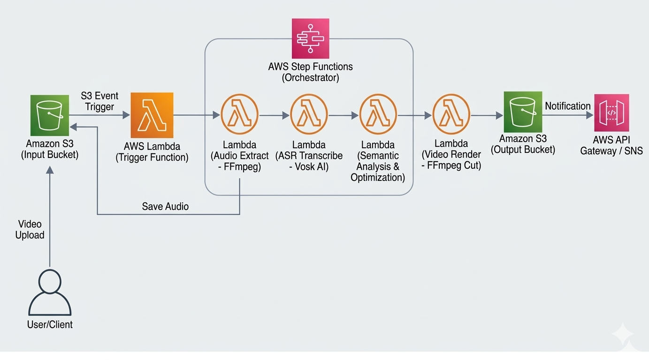
Figure 2 : Proposed System Architecture
The system architecture is illustrated in Figure 2. As shown, the process begins with the user uploading a video to the input S3 bucket, which triggers backend execution. The workflow then proceeds through multiple Lambda functions coordinated by Step Functions, where each function performs a specific task such as audio extraction, speech-to-text conversion, semantic analysis, and video clipping. Finally, the generated highlight clip is stored in the output bucket and made available to the user.

5.3 System Methodology
The methodology of the proposed system follows a sequential processing approach in which each stage contributes to automatic highlight extraction. The complete process is divided into functional modules for better organization and execution control.
The workflow begins with video upload through the frontend interface, after which the file is securely stored in cloud storage and automatically triggers backend execution. Each module performs a dedicated operation and passes its output to the next stage in the workflow.
By separating audio extraction, speech recognition, semantic analysis, timestamp generation, and clip rendering into different stages, the system maintains clear execution flow and reduces processing complexity. This modular design also improves maintainability because individual stages can be updated independently. It further supports reliable serverless execution by ensuring that each function runs only when triggered by the previous stage.

5.3.1 Upload and Trigger Mechanism
The process begins when the user uploads a long-form video through the frontend interface. Before upload, a secure presigned URL is generated by the backend so that the video can be directly stored in S3. This method improves upload security and reduces backend transfer load.
After successful upload, the S3 storage bucket generates an event trigger which automatically activates the first processing function. This event-driven initiation eliminates the need for manual backend execution and allows immediate workflow activation.

5.3.2 Audio Extraction Module
The uploaded video is processed by the extract_audio function, which uses FFmpeg to separate audio content from the original video. Audio extraction is necessary because speech content carries the semantic information required for highlight identification.
The extracted audio file is stored temporarily for the next stage of processing. This stage reduces computational load because only speech content is forwarded for transcription rather than the complete video stream.

5.3.3 Speech-to-Text Module
The extracted audio is passed to the speech_to_text function where Vosk performs speech recognition. Vosk converts spoken audio into timestamped transcript output.
Timestamp generation is important because each transcript segment must later be mapped back to the corresponding video segment. The generated transcript forms the core input for semantic analysis.

5.3.4 Semantic Analysis Module
The transcript generated in the previous stage is analysed by the ai_analyzer module. Semantic scoring identifies portions of speech that contain high informational density, emotional importance, or content relevance. This concept is inspired by modern video summarization techniques that focus on identifying meaningful segments within video content [1], [5], [6].
To improve contextual understanding, Google Gemini API is used for intelligent content filtering and clip recommendation. Gemini helps identify transcript regions that are likely to produce meaningful short-form content by analysing sentence importance and contextual relationships within the transcript.

5.3.5 Timestamp Identification
After semantic scoring, the identified transcript segments are converted into exact video timestamps. The start and end points of important speech segments are selected carefully to maintain continuity in the final clip.
This timestamp mapping ensures that the selected highlight contains complete semantic meaning and natural video continuity. Proper timestamp alignment also prevents abrupt cuts and helps preserve smooth playback in the generated short video.

5.3.6 Video Rendering Module
The video_cutter function uses FFmpeg to cut the selected segment from the original video file. The module receives timestamp values from the previous stage and extracts only the required portion of the uploaded video.
Instead of full video re-encoding, stream-copy methods are used wherever possible to reduce rendering time and cloud resource consumption. The generated short clip is then stored in the output bucket for retrieval through the frontend interface.

5.3.7 Workflow Orchestration
The complete sequence of processing stages is controlled through AWS Step Functions. Step Functions divide the full pipeline into individual states where each Lambda executes independently. This orchestration mechanism ensures that every stage starts only after the successful completion of the previous stage, maintaining proper execution flow throughout the system.
This orchestration layer handles:
- State transitions
- Execution order
- Failure recovery
- Retry management
In addition, Step Functions provide visual monitoring of workflow execution, making it easier to track processing progress and identify errors during runtime. This design allows long-form videos to be processed reliably within serverless execution limits while improving overall system stability and maintainability.

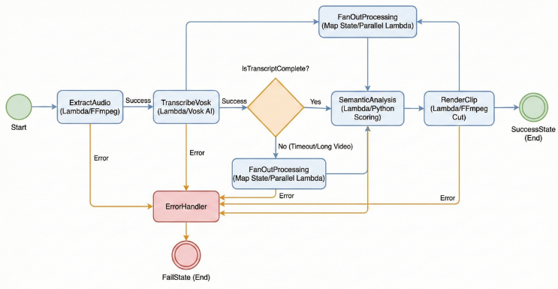
Figure 3 : Workflow Orchestration Using AWS Step Functions
The workflow orchestration is illustrated in Figure 3. As shown, the execution is managed through AWS Step Functions, where each state represents a specific Lambda processing stage. The workflow progresses through sequential states for audio extraction, transcription, semantic analysis, and video rendering. Success transitions move the execution forward, while error transitions handle failures through retry or fallback mechanisms, ensuring reliable and modular execution of the highlight generation process.

Chapter 6

Experimental Setup

6.1 Frontend Setup
The frontend of the proposed system is developed using React.js to provide a responsive and interactive interface for video upload, processing status monitoring, and output retrieval. The frontend enables users to upload long-form videos, initiate serverless processing, and view generated short clips after completion. Navigation between different functional pages is handled through routing, where separate views are provided for video processing and output display. The user interface is designed with a lightweight glass-based visual style to improve usability and modern presentation.

6.1.1 Frontend Technologies Used
- React – Component-based user interface development
- HTML – Interface structure
- CSS – Interface styling
- JavaScript (ES6+) – Client-side logic
- React Router DOM – Navigation between pages
- Glass UI with blur effects – Visual design implementation

6.1.2 Frontend Structure
The frontend follows a modular structure consisting of:
- Upload page for selecting and submitting video files
- Processing page for tracking workflow progress
- Output page for displaying generated short clips
- API communication module for cloud requests
This structure ensures efficient interaction between user actions and the serverless backend pipeline.

6.2 Backend Setup
The backend of the proposed system is implemented using a serverless cloud architecture where each processing task is executed independently through cloud functions. The backend handles file upload preparation, audio extraction, transcription, semantic analysis, clip generation, and status retrieval. The complete workflow is automatically triggered after video upload and processed through multiple specialized serverless modules.

6.2.1 Backend Technologies Used
- Python 3.9 – Core backend programming language
- AWS Lambda – Serverless execution layer
- Amazon S3 – File storage layer
- FFmpeg – Audio extraction and video cutting
- Vosk – Speech-to-text transcription
- NumPy – Semantic score calculations

6.2.2 Backend Structure
The backend is organized into separate Lambda functions, where each function performs a dedicated stage of processing:
- get_upload_url – Generates presigned S3 upload URL
- start_step_function – Starts workflow after upload
- extract_audio – Extracts audio using FFmpeg
- speech_to_text – Performs speech recognition using Vosk
- ai_analyzer – Selects important clips using semantic analysis
- video_cutter – Cuts final video segments
- job_status – Retrieves workflow execution status
This modular backend structure improves scalability and fault isolation.

6.2.3 API Communication
The system uses cloud API communication to connect frontend requests with backend processing services.
- Amazon API Gateway handles REST endpoints
- /upload-url endpoint generates upload link
- /job-status endpoint fetches processing status and output
In addition to internal cloud communication:
- S3 event trigger initiates backend workflow
- Lambda outputs are passed through Step Functions
- Google Google Gemini API is used for intelligent clip selection, semantic understanding, and content filtering

6.3 Development Environment
The development of the proposed system is carried out locally before cloud deployment. Each module is tested independently before integrating with the serverless workflow.

6.3.1 Software Requirements
- Visual Studio Code – Code editor
- Windows Operating System – Development platform
- Python 3.9 – Backend runtime
- Node.js – Frontend runtime
- FFmpeg installed locally – Media processing
- AWS account – Cloud deployment

6.3.2 Development Setup
The development setup includes both frontend and backend configuration before deployment. Local development was carried out to test each module independently before integrating all components into the cloud workflow. This allowed functional verification of frontend interaction, API communication, and media processing before deployment.
- JavaScript runtime environment (Node.js) configured locally
- Python dependencies installed for Lambda development
- FFmpeg binary added for media processing
- Vosk model downloaded for transcription
- Cloud functions deployed after local testing
Frontend modules were tested through local execution to verify page navigation, file upload handling, and API response integration. Backend functions were validated separately before deployment to ensure that media processing and transcript generation worked correctly within the serverless environment. This setup ensures compatibility between local development and cloud-based serverless execution.

Chapter 7

Results & Discussion
The proposed Serverless Video Editor was evaluated by executing the complete workflow from video upload to final short generation under actual deployment conditions. The testing phase was carried out to verify whether all integrated modules of the system operate correctly when connected through the serverless cloud pipeline. The implementation included frontend interaction, backend API communication, cloud storage events, Lambda execution, workflow orchestration, transcript analysis, and final output retrieval.
During testing, uploaded video files were successfully accepted through the frontend interface and transferred to cloud storage using secure upload mechanisms. After upload, the backend workflow automatically started through event-based triggers. The system processed the uploaded content through sequential stages including audio extraction, speech recognition, semantic analysis, and clip rendering. Once processing was completed, the final short clip was stored in cloud output storage and displayed to the user through the frontend interface.
The results confirm that the proposed system successfully automates short-form video generation without manual editing intervention. The cloud-native design also ensured efficient resource usage because processing resources were activated only during execution. Important outputs obtained during implementation are discussed below.

7.1 Frontend Processing Result
The frontend interface serves as the primary interaction layer between the user and the system. It was developed using React and designed to provide a simple workflow for video upload, execution monitoring, and output retrieval. The interface includes navigation features such as home, login, signup, dashboard, and output access, allowing users to interact with the complete system without technical complexity.
During testing, after the user uploaded a video, the frontend immediately redirected to the processing screen. A unique job ID was generated for each uploaded file, which was displayed to the user for tracking backend execution. This job ID also served as the reference used by backend APIs to retrieve processing status.
The frontend continuously sent status requests to the backend through API Gateway. Until processing completed, the system displayed a status message indicating that backend execution was in progress. This allowed the user to monitor execution without manually refreshing the page.
The successful functioning of this interface confirms that frontend-backend integration through API communication was established correctly.
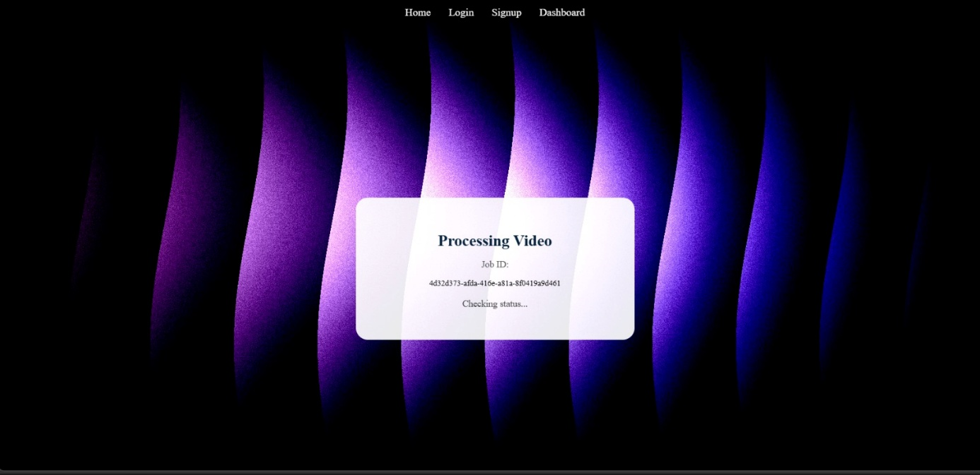
Figure 4 : Frontend Processing Interface
The frontend processing interface is illustrated in Figure 4. As shown, the screen is displayed immediately after video upload, where a unique job ID is generated to identify the processing request. The status section continuously monitors backend execution by checking processing progress until completion.

7.2 Serverless Workflow Execution Result
The core backend execution of the proposed system is managed through AWS Step Functions. Step Functions coordinate the execution of multiple Lambda functions in a predefined sequence so that each processing stage executes only after the previous stage completes successfully.
The execution begins with the ExtractAudio state, where audio is separated from the uploaded video using media processing tools. After audio extraction, the SpeechToText stage converts spoken content into transcript form using speech recognition. The generated transcript is then passed to the AIAnalyzer stage, where semantic scoring identifies important segments of speech content. Finally, the VideoCutter stage extracts the selected highlight segment from the original video.
During implementation testing, the Step Function execution graph clearly showed successful movement across all processing states. Each state completed sequentially without failure, confirming correct integration between cloud storage triggers, Lambda functions, and workflow orchestration.
This modular execution design improves fault isolation because errors in one state do not affect the entire workflow structure. It also improves scalability because each function executes independently.
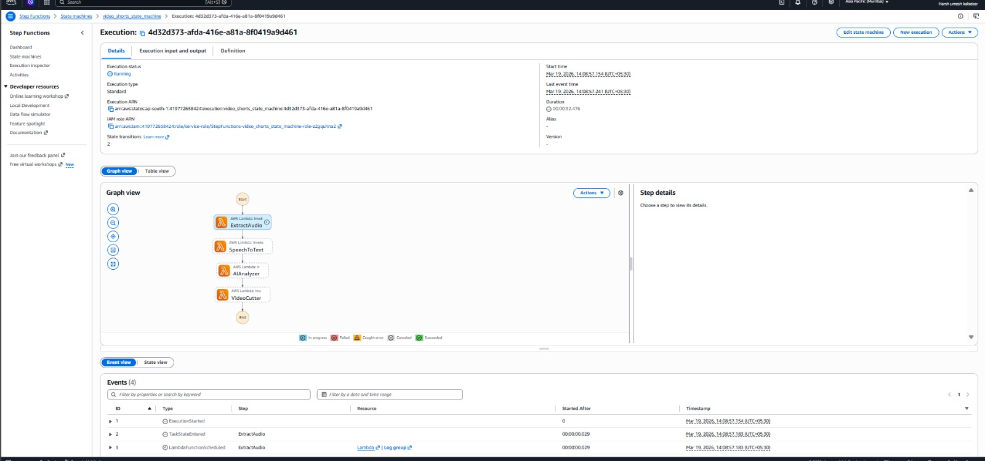
Figure 5 : Workflow Execution in AWS Step Functions
The Step Function execution workflow is illustrated in Figure 5. As shown, each state corresponds to one processing stage, beginning with ExtractAudio and continuing through SpeechToText, AIAnalyzer, and VideoCutter until the workflow reaches completion.

7.3 Output Generation and Final Result
After successful completion of backend execution, the generated short clips were stored in the output cloud storage bucket and retrieved through frontend output APIs. The frontend then displayed the generated clips to the user in a preview section.
The output interface allowed direct playback of generated short videos without requiring additional download. A download option was also provided so that users could save the generated short clip locally.
The generated results confirmed that transcript-based semantic analysis successfully identified important speech segments and that media rendering correctly extracted corresponding highlight clips from the original long-form video. This demonstrates that the proposed system performs automatic short generation effectively.
The quality of output also confirms that the selected cloud-based rendering process preserved video continuity and generated clips suitable for short-form digital sharing.
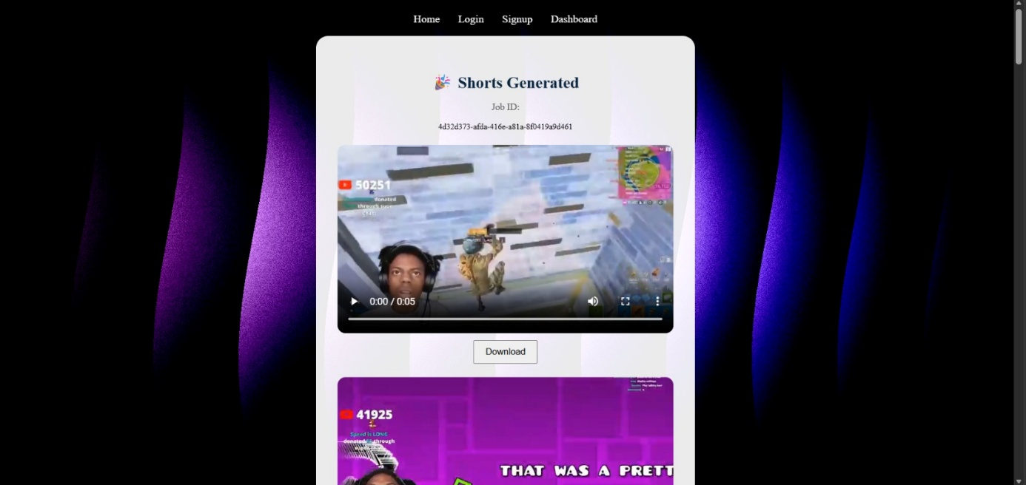
Figure 6 : Generated Short Video Output
The generated output is illustrated in Figure 6. As shown, the final short clip is displayed in the frontend output interface, where the user can preview the generated video and download it after processing completes.
Chapter 8

Conclusion & Future Scope

8.1 Conclusion
This paper presented a Serverless AI-Based Automated Video Highlight Extraction System for Short-form Content Generation that automates the process of extracting important short clips from long-form videos. The proposed system combines speech-to-text transcription, semantic analysis, and serverless cloud execution to reduce manual editing effort and overall processing cost. Unlike traditional video editing systems that require high-performance hardware and continuous server availability, the proposed framework uses AWS Lambda and AWS Step Functions to provide scalable event-driven processing only when video uploads occur.
The system integrates Vosk for localized speech-to-text transcription and FFmpeg for efficient video clipping, allowing highlight generation without GPU dependency. By selecting semantically important transcript segments, the framework generates short clips suitable for social media platforms while keeping processing lightweight and cost-effective. Experimental observations indicate that the system reduces operational expenses while maintaining reliable highlight extraction performance across different content categories. Overall, the proposed framework demonstrates that serverless orchestration and lightweight semantic analysis can provide an affordable and scalable solution for automated short-form content generation.

8.2 Future Scope
Although the proposed system provides an efficient foundation for automated highlight extraction, several improvements can be explored in future work to enhance accuracy, flexibility, and real-time usability. One important direction is the integration of real-time live video processing, where highlights can be generated dynamically during live lectures, events, or streaming sessions. This would extend the system from post-processing workflows to near real-time content generation, making it more useful for live media environments.
Another major enhancement involves the incorporation of lightweight multimodal models capable of combining speech, facial expression, and scene-level visual understanding. At present, the semantic scoring process primarily relies on transcript information, which may reduce performance in cases involving sarcasm, emotional reactions, or visually important events that are not explicitly reflected in speech. Future integration of multimodal analysis can improve contextual understanding while maintaining lightweight execution suitable for serverless environments.
The system can also be extended toward multilingual transcription and language-independent semantic analysis, allowing highlight generation for videos containing multiple languages or regional speech patterns. In addition, future versions may include adaptive resource allocation where cloud memory and timeout parameters are dynamically selected based on video duration and complexity, improving cost optimization further. Deployment across multi-cloud or edge computing platforms may also reduce cold-start latency and improve performance for geographically distributed users. These enhancements would allow the proposed framework to evolve into a more intelligent, scalable, and production-ready automated media processing system.

References
- K. Zhou, Y. Qiao, and T. Xiang, “Video summarization using deep reinforcement learning,” in Proc. AAAI Conf. Artificial Intelligence, 2018.
- K. Zhou, Y. Qiao, and A. Cavallaro, “Video summarisation by classification with deep reinforcement learning,” in Proc. British Machine Vision Conf. (BMVC), 2018.
- J. Mahasseni, M. Lam, and S. Todorovic, “Unsupervised video summarization with adversarial LSTM networks,” in Proc. IEEE Conf. Computer Vision and Pattern Recognition (CVPR), 2017.
- K. Zhou, Y. Qiao, and T. Xiang, “Deep summarization network: Unsupervised video summarization by learning from data,” in Proc. IEEE Conf. Computer Vision and Pattern Recognition (CVPR), 2016.
- B. Panda, A. K. Roy-Chowdhury, and R. M. Ewerth, “SUM-GAN: Summarization of videos using generative adversarial networks,” in Proc. AAAI Conf. Artificial Intelligence, 2018.
- J. Fajtl, V. Argyriou, D. Monekosso, and P. Remagnino, “Summarizing videos with attention,” in Proc. IEEE Conf. Computer Vision and Pattern Recognition (CVPR), 2019.
- Y. Zhang, X. He, and J. Luo, “A comprehensive survey on video summarization techniques,” ACM Computing Surveys, vol. 54, no. 3, 2021.
- A. G. Money and H. Agius, “Video summarisation: A conceptual framework and survey of the state of the art,” Journal of Visual Communication and Image Representation, vol. 19, no. 2, pp. 121–143, 2008.

